**Mainframes DXC Australia**

**Assessment 4: JCL, COBOL, & CICS**

**By: Pranay Yara**

**26/07/2024**

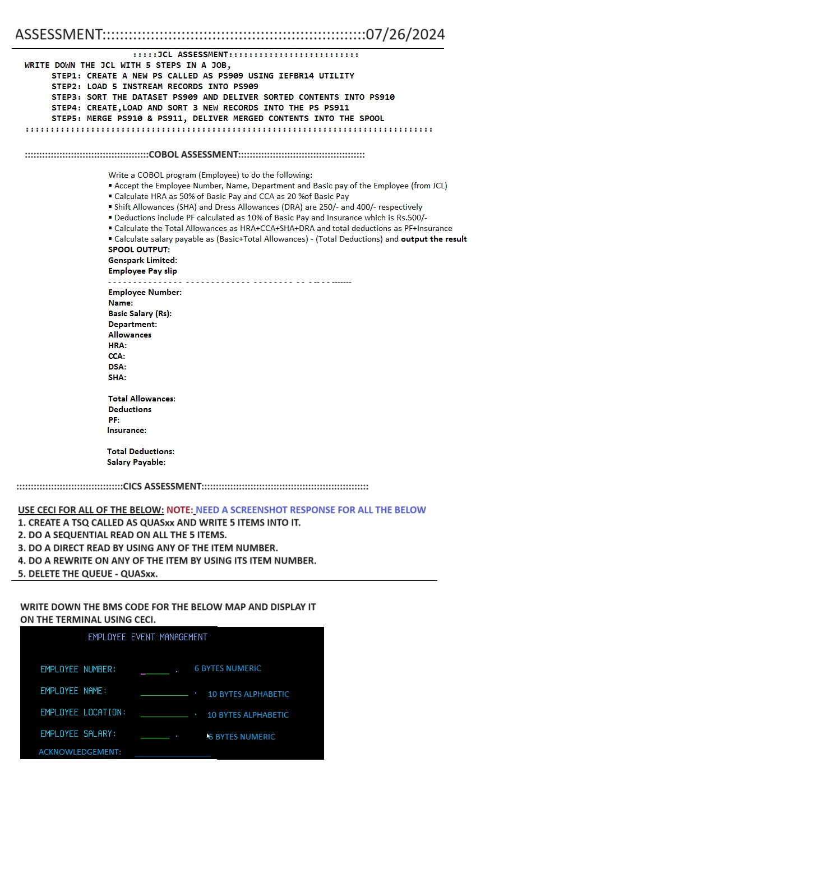

**JCL ASSESSMENT**

**Comments**: I completed this on my first submission - I had no errors!

**Code**: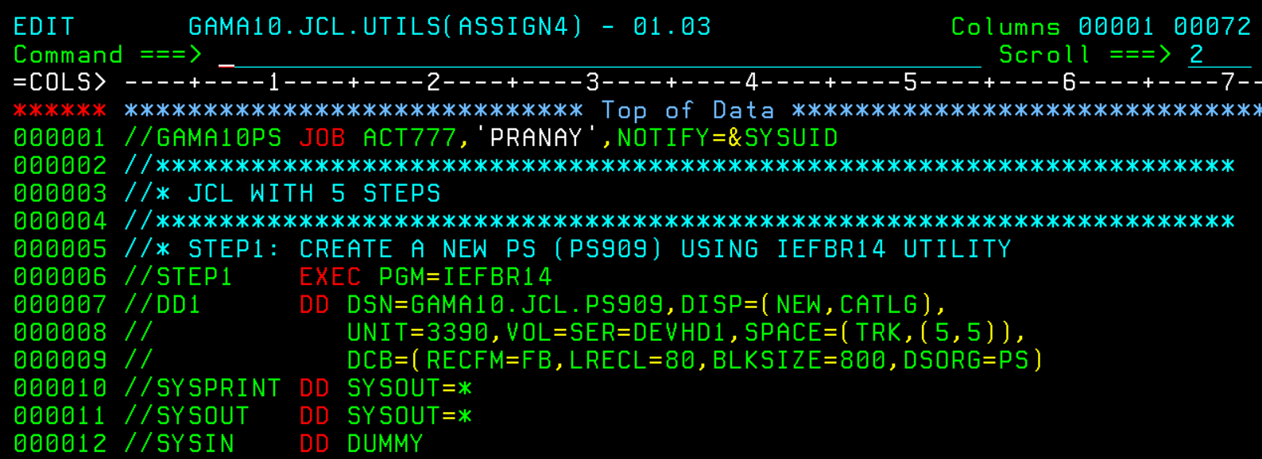

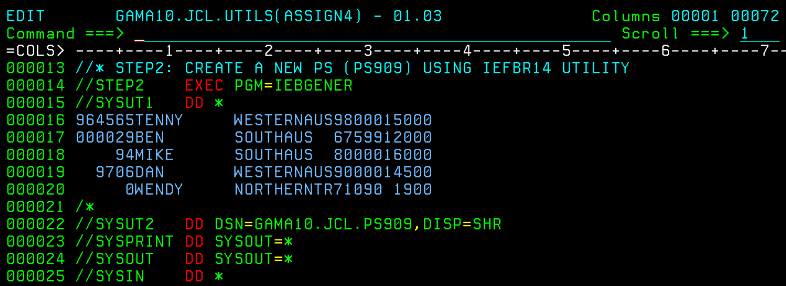

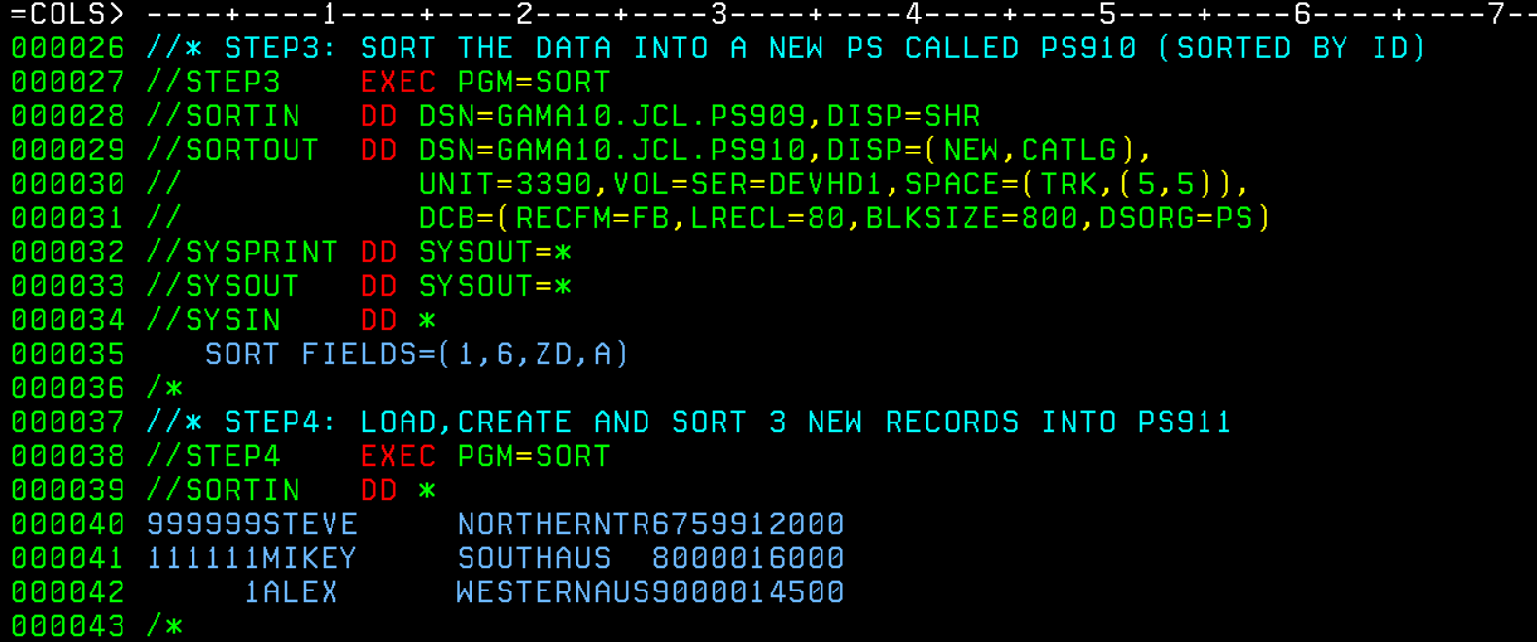

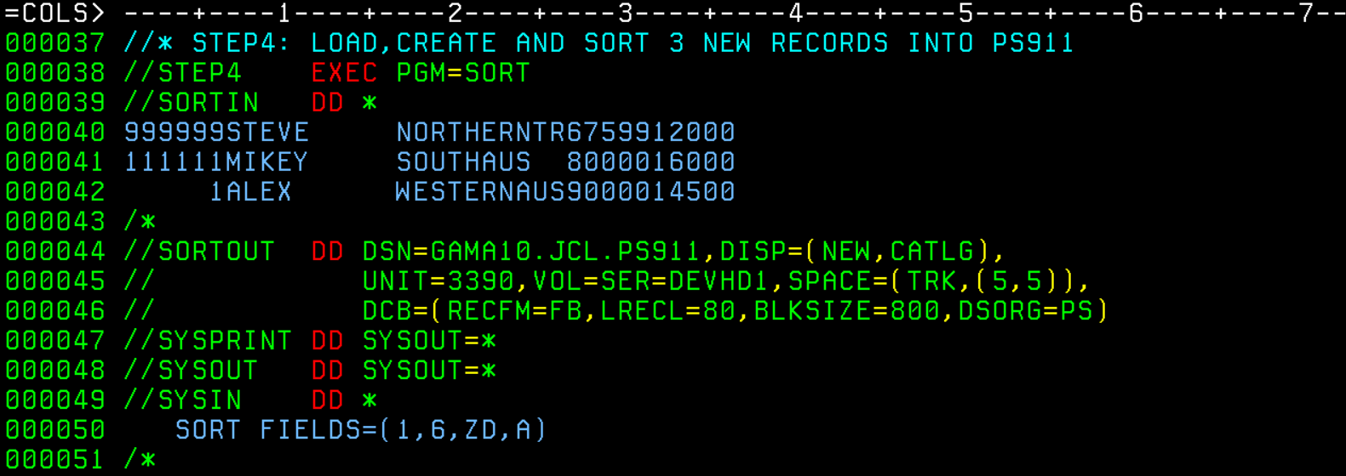

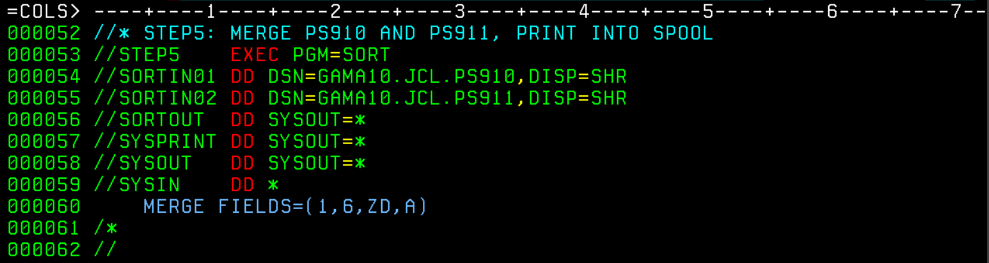

**Outputs:**

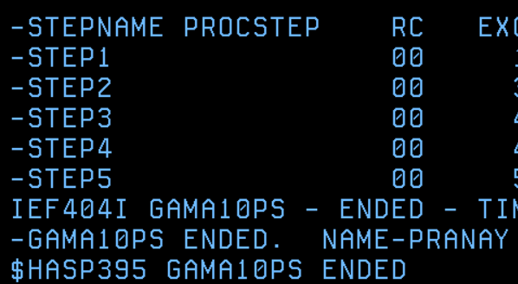

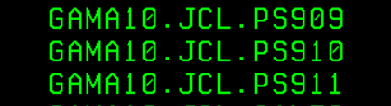

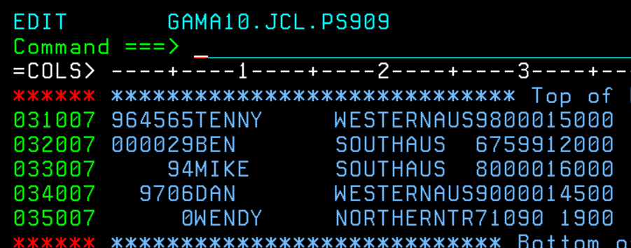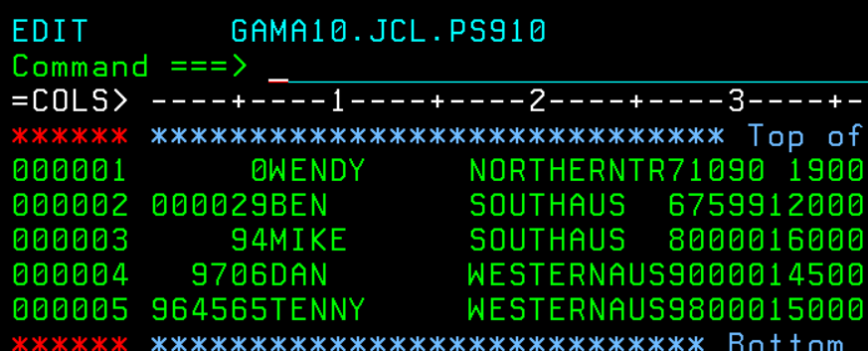

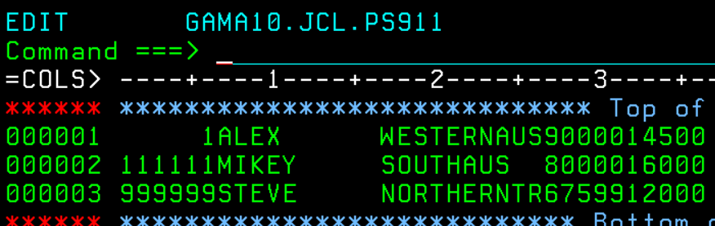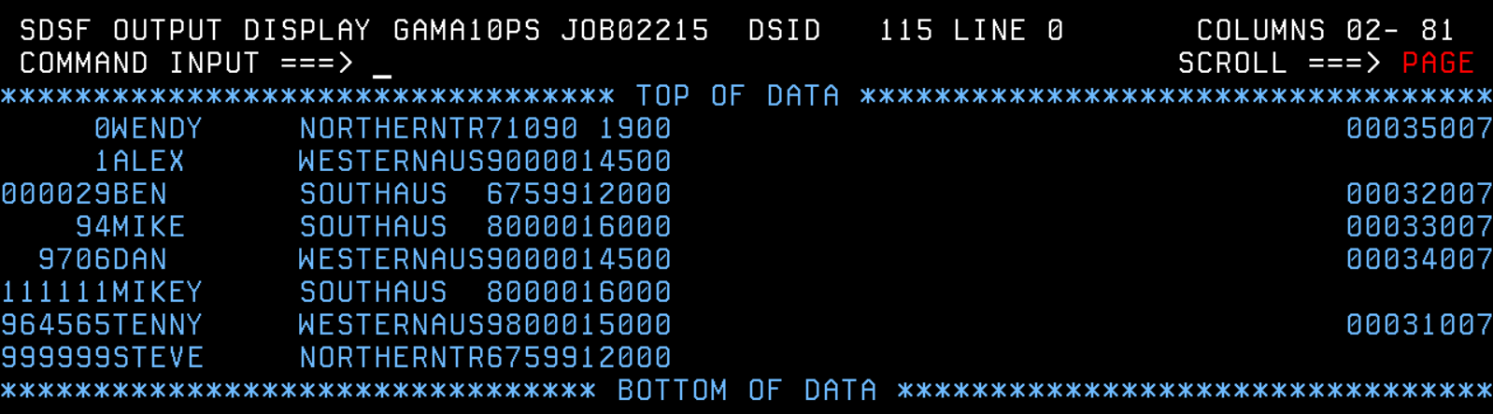

**COBOL ASSESSMENT**

**Comments**: I didn’t face any major errors for this part, just names weren’t matching and I miscalculated the final value but I was able to swiftly rectify all those small errors.

**Code**: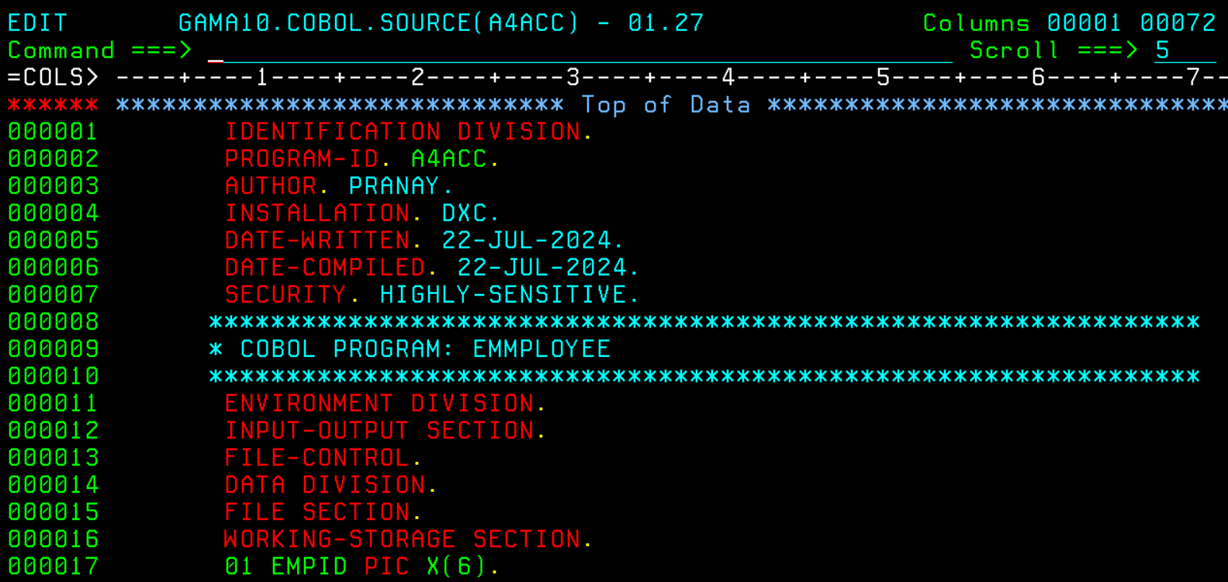

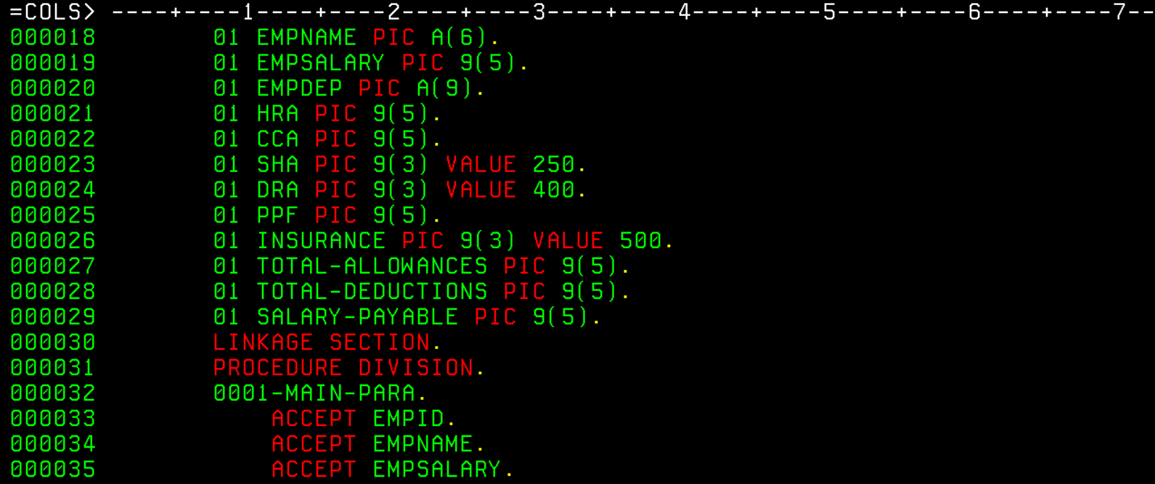

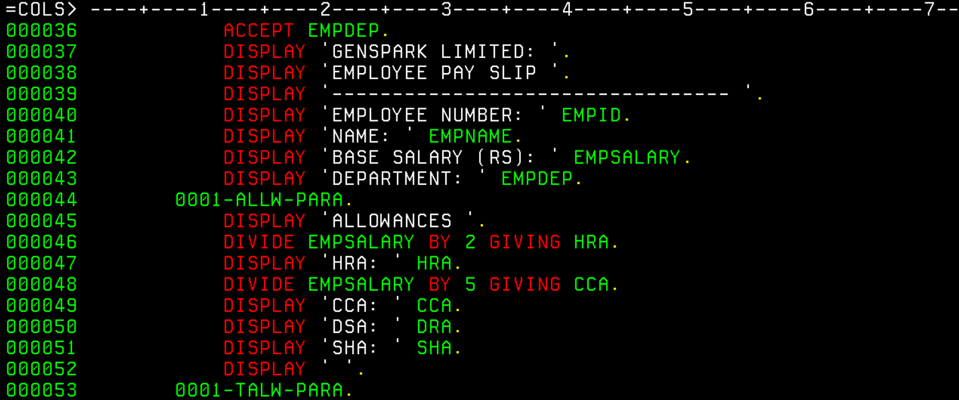

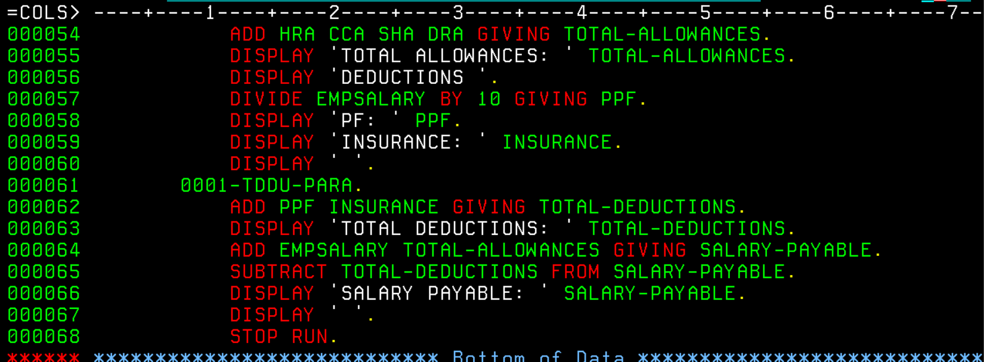

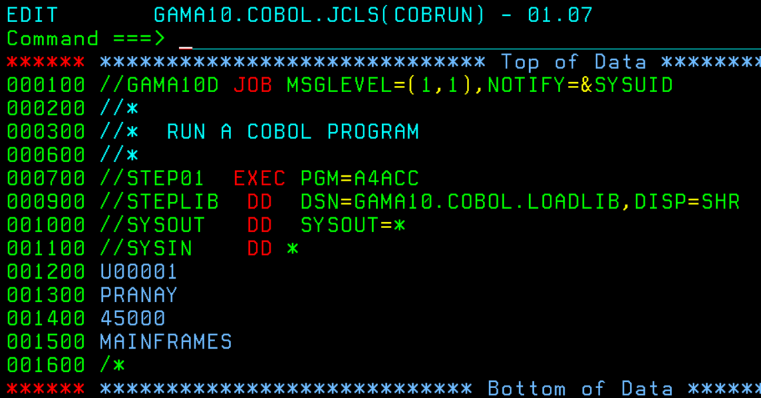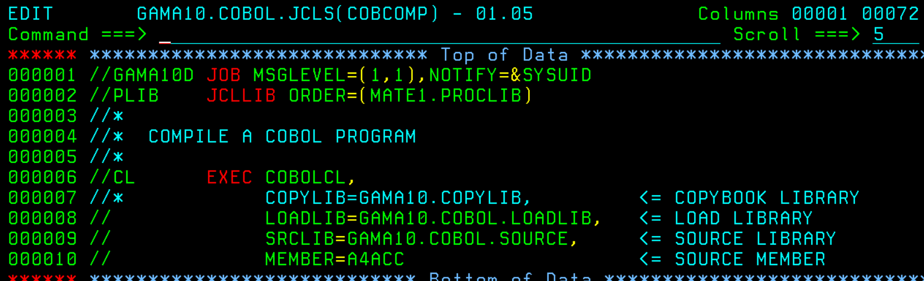

**Outputs:**

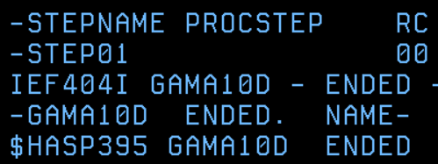

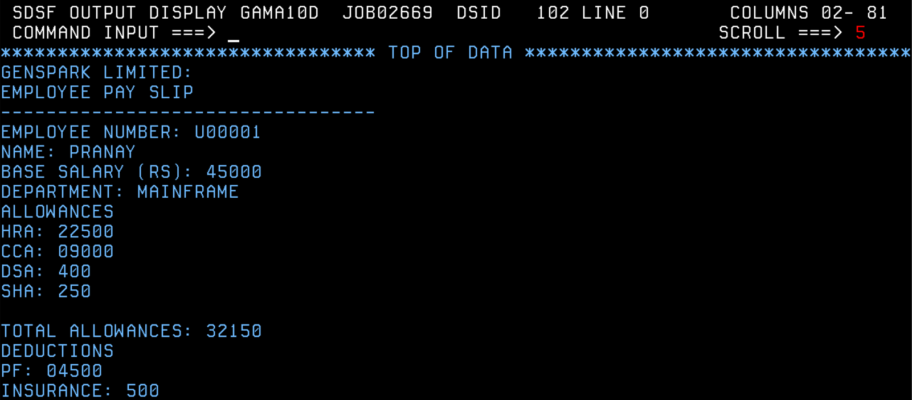

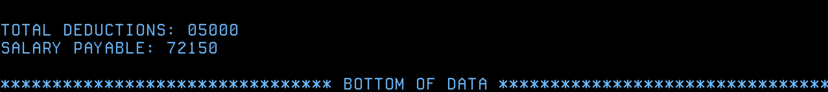

**CICS ASSESSMENT**

**1. CREATE A TSQ CALLED AS QUASXX AND WRITE 5 ITEMS INTO IT.**

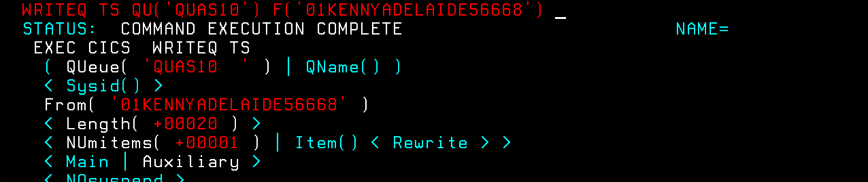

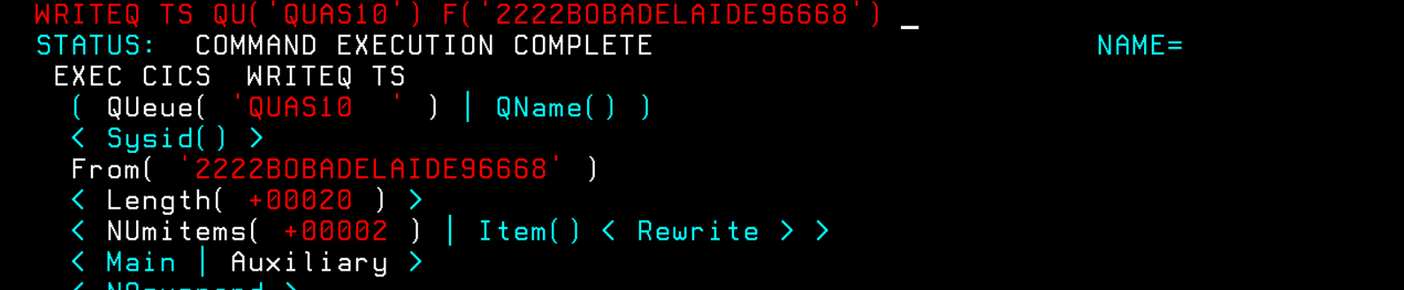

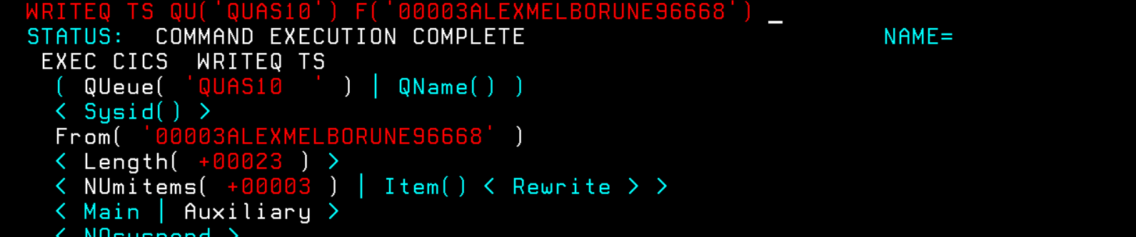

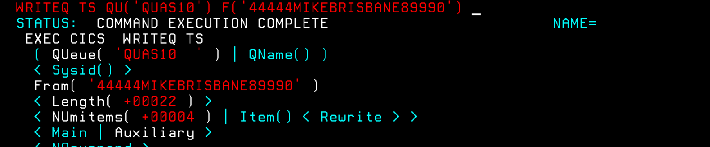

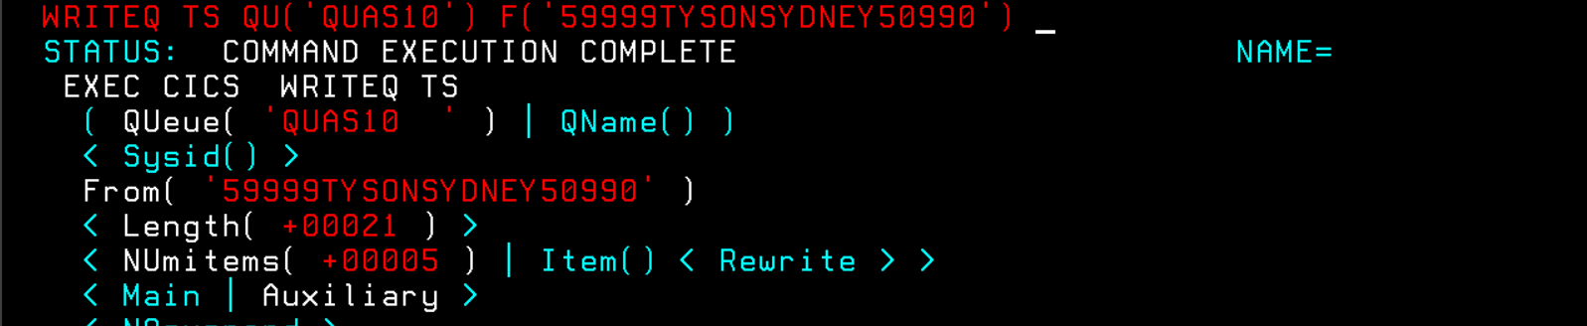

**2. DO A SEQUENTIAL READ ON ALL THE 5 ITEMS.**

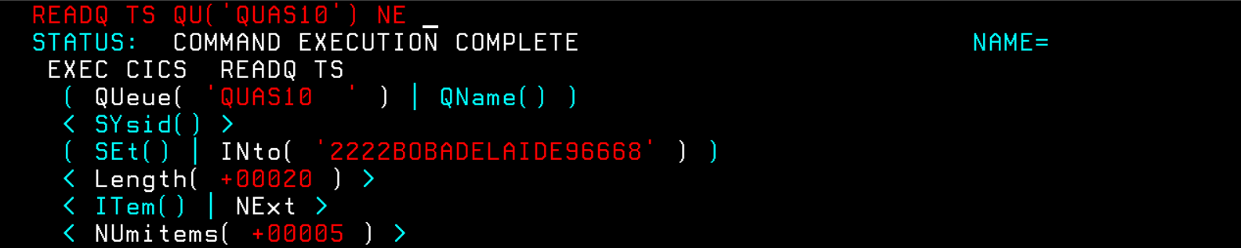

**3. DO A DIRECT READ BY USING ANY OF THE ITEM NUMBER.**

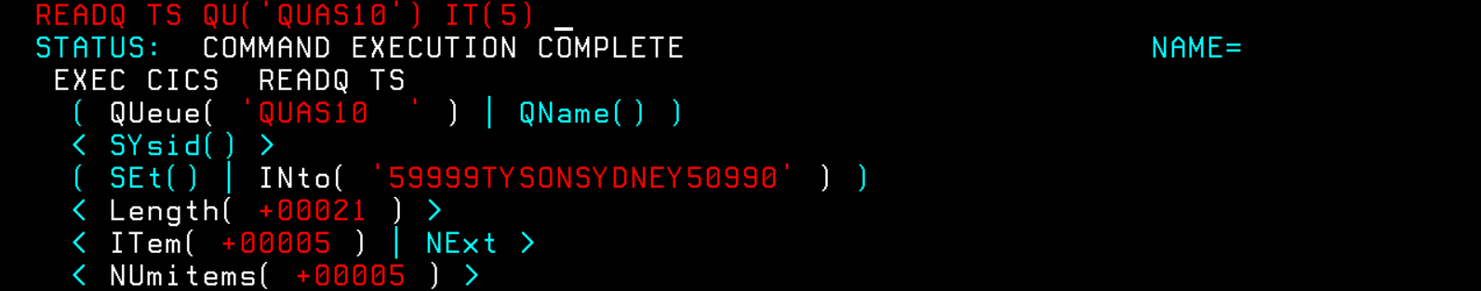

**4. DO A REWRITE ON ANY OF THE ITEM BY USING ITS ITEM NUMBER.**

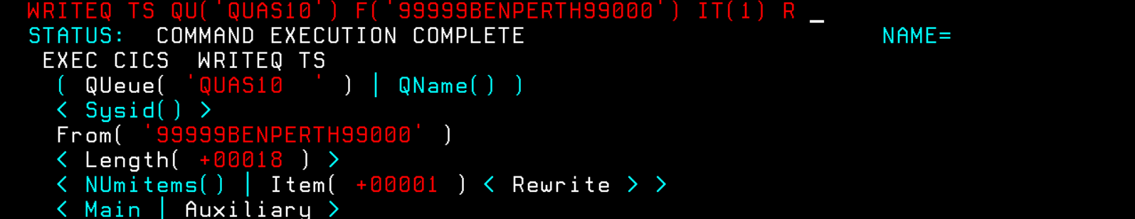

**4.1. PRINTING THE ENTIRE QUEUE.**

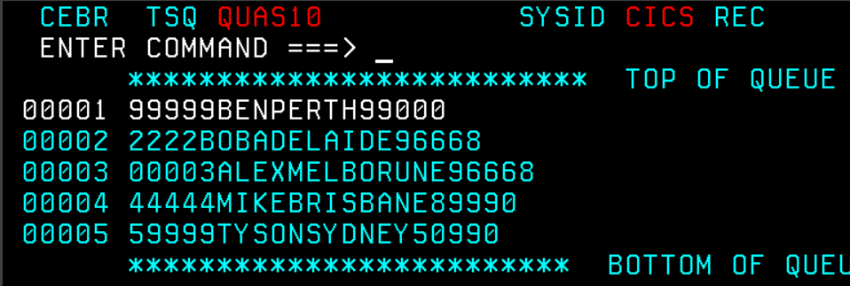

**5. DELETE THE QUEUE - QUASXX.**

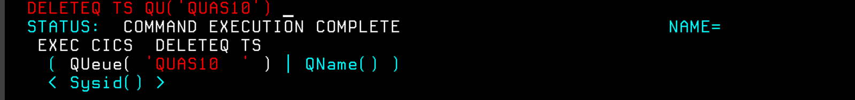

**BSM CODE:**

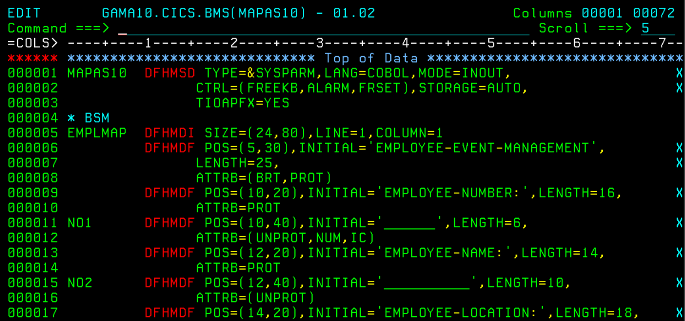

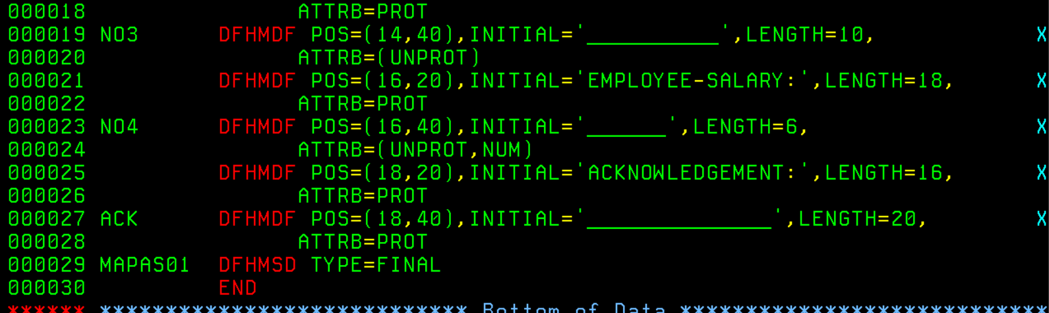

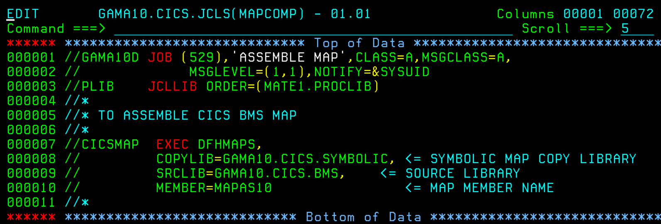

**OUTPUT:**

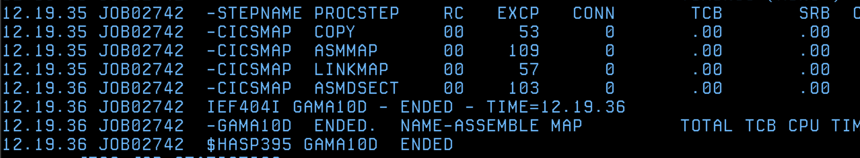

**DEFINE AND INSTALL IN CICS:**

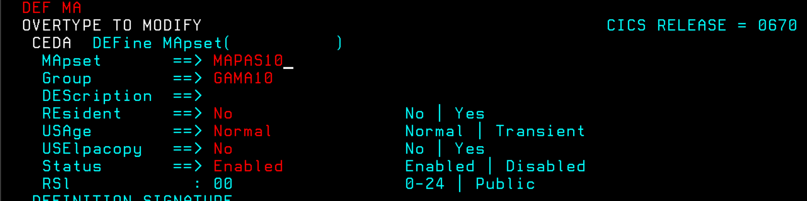

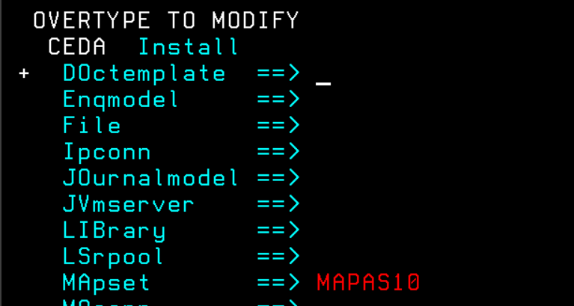

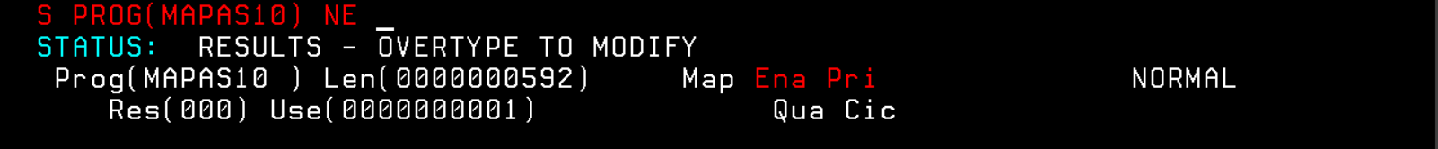

**PRINTING THE MAP:**

